NEWS RELEASE
LEARN HOW TO FORM DISCIPLES AT MAY TRAINING INSTITUTE
Join us May 4-6, 2017 for the Catechumenate Training Institute “Go Baptize, Make Disciples”. Learn what it means to be a discipleship congregation at the upcoming institute being held at Lutheran Church of the Nativity in Arden (Asheville), North Carolina. Pastors, musicians, seminarians, and lay leaders are encouraged to attend this event being offered by the North American Association for the Catechumenate (NAAC) and sponsored by the North Carolina Synod of the Evangelical Lutheran Church in America.

North Carolina Synod Bishop Tim Smith indicates that this training is not only for members of the North Carolina Synod but is open to anyone including members of other denominations. Participants will experience all four stages of a faith formation process that invites people into baptismal living. They will be immersed in the rites and rituals of this ancient-future Christian practice called the Catechumenate. They will receive resources including a copy of Go Make Disciples (Augsburg Fortress) and learn how to introduce this journey of discipleship to their congregations.

Full scholarships are available for students and seminarians. For more information call Lutheran Church of the Nativity at 828-684-0352 or contact Pastor Mark Fitzsimmons (mfitzsimmons@nativityarden.org) or Pastor Rachel Hoffman (rhoffman@nativityarden.org). One can download a brochure and/or register online at the NAAC website: www.catechumenate.org

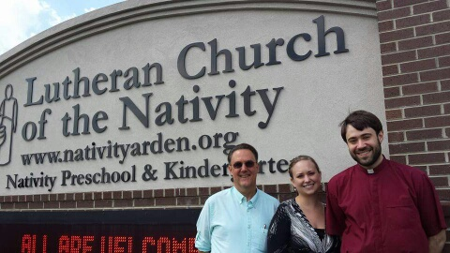

Pastors Mark Fitzsimmons, Rachel Hoffman, and Greg Hoffman invite you to join them in Asheville, North Carolina in May 2017.

